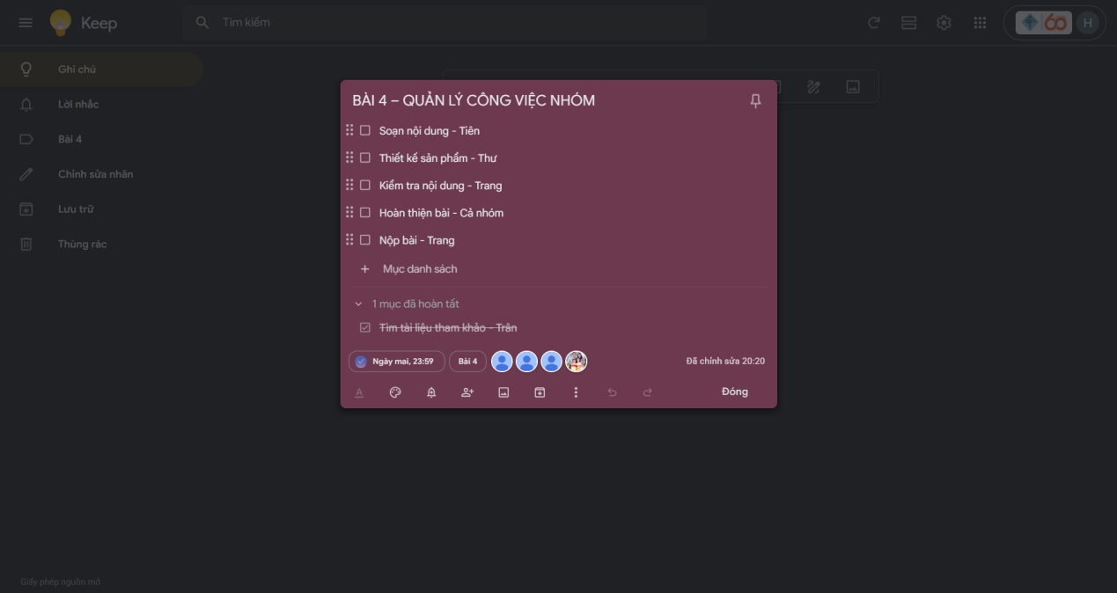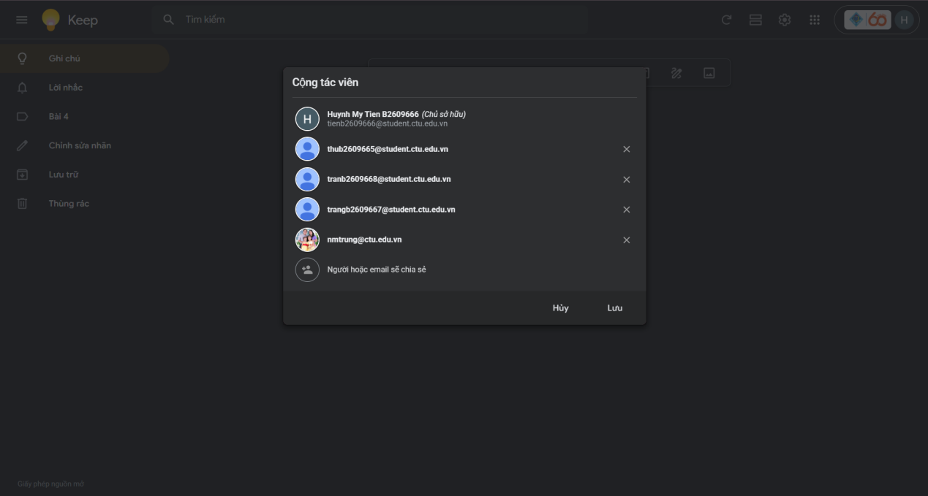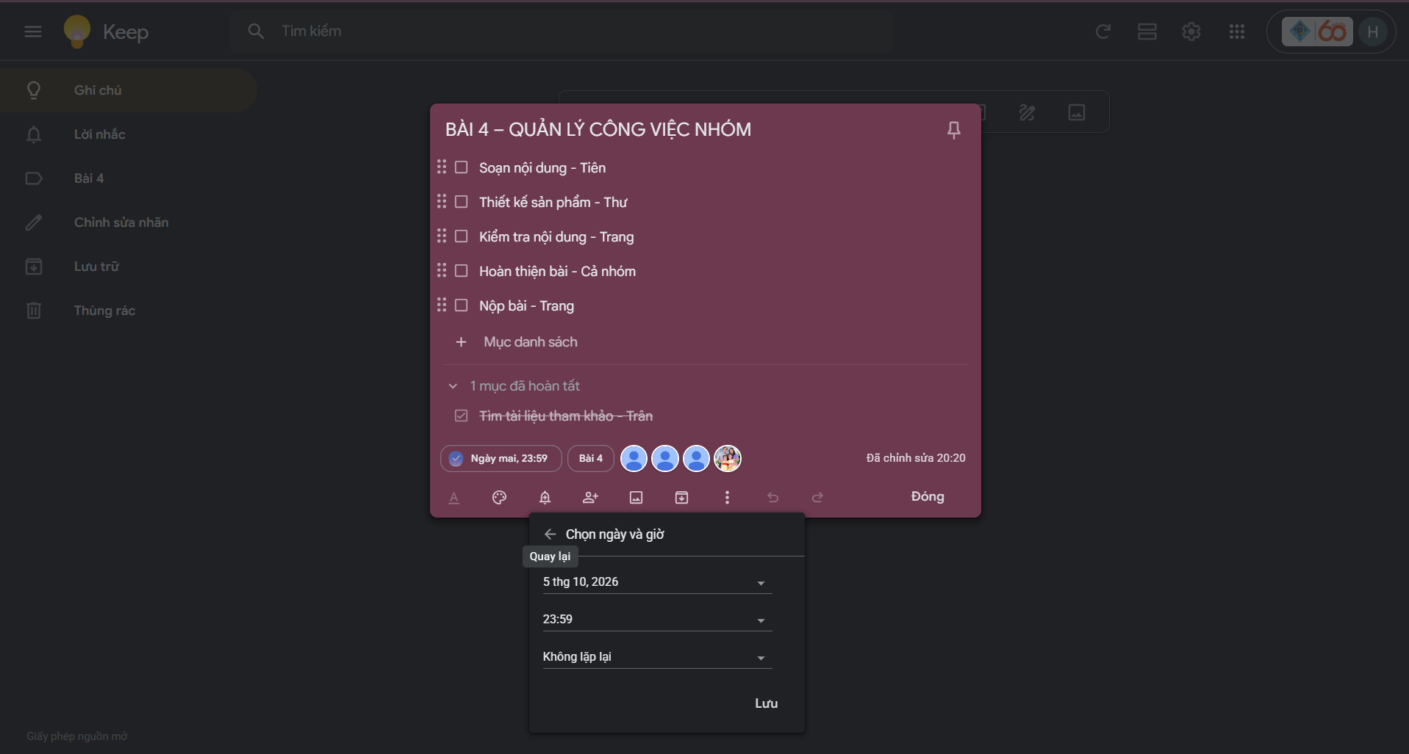
Địa chỉ gg Keep: https://keep.google.com/u/0/#LIST/1S6Pmx-R9WR4CkBNE52nB42BCIu9Ezndg_ktnlGzClHhXXUNwBwU8Fo7ZVPbGC1Y

